CHAPTER 2 GEOGRAPHY

UNDERSTANDING WEATHER

1.Weather vs. Climate
Feature | Weather | Climate
Definition | The hour-to-hour or day-to-day condition of the atmosphere at a specific plac | The average weather pattern of a place over a long period of time (usually 30–35 years).
Duration | Short-term; changes rapidly (can change from sunny to rainy within an hour). | Long-term; remains relatively stable over decade
Area Covered | Refers to a small localized area (e.g., a city or town). | Refers to a vast region or entire country
Example | "Today it is hot and humid, but it might rain in the evening." | India has a tropical monsoon climate

2. Elements of Weather
​The condition of the atmosphere depends on several basic factors called the elements of weather.

​1. Temperature
- Definition: Temperature is the degree of hotness or coldness of the air. It depends heavily on insolation (incoming solar radiation intercepted by the earth).
- ​Impact: It determines how warm or cold a day feels and influences air pressure.

​2. Atmospheric Pressure
- ​Definition: The pressure exerted by the weight of air on the earth's surface.
- ​Behaviour: As we go up the layers of the atmosphere, pressure falls rapidly. Air pressure is highest at sea level and decreases with height.
- ​Rule: Hot air rises (creating low pressure), while cold air sinks (creating high pressure).

​3. Wind
- ​Definition: The movement of air from high-pressure areas to low-pressure areas.
- ​Types: It can be a gentle breeze, a strong steady wind, or a powerful storm/cyclone.

​4. Humidity
- ​Definition: The amount of moisture or water vapor present in the air at any given time.
- ​Impact: When the air is full of water vapor, we call it a humid day. Hot air can hold more water vapor than cold air.

​5. Precipitation
- ​Definition: The process by which condensed water vapor falls back to the earth's surface under gravity.
- ​Forms: It occurs in various forms such as rain, snow, sleet, or hail, depending on the temperature.

​

Weather Instruments
​To measure and record the variations in weather elements, meteorologists use specific instruments.

​A. Thermometer
- ​Definition: An instrument used to measure the air temperature.
- ​Types: * Celsius Scale Thermometer: Standard thermometer used for daily weather recording.
- ​Units of Measurement: Measured in Degree Celsius (°C) (invented by Anders Celsius) or Fahrenheit (°F). On the Celsius scale, water freezes at 0°C and boils at 100°C.

​B. Rain Gauge
- ​Definition: An instrument used to measure the amount of rainfall received over a specific period of time.
- ​Mechanism: It consists of a copper or plastic cylinder containing a funnel and a graduated measuring jar. Rainfall is typically collected and recorded in millimeters (mm) or centimeters (cm).

​C. Wind Vane
- ​Definition: An instrument used to show the direction from which the wind is blowing.
- ​Mechanism: It consists of an arrow mounted on a central axis that rotates freely. The arrow points toward the direction the wind is coming from (e.g., if it points North, it is a North wind).

​D. Anemometer
- ​Definition: An instrument used to measure the speed of the wind.
- ​Mechanism: It usually features three or four metal cups fixed onto horizontal arms that rotate when the wind blows. The speed of rotation indicates the wind velocity, measured in km/h or knots.

​E. Hygrometer
- ​Definition: An instrument used to measure the humidity or the amount of moisture present in the air.
- ​Mechanism: It tracks the relative humidity of the atmosphere and displays the result as a percentage (%). A common type is the wet-and-dry bulb thermometer.
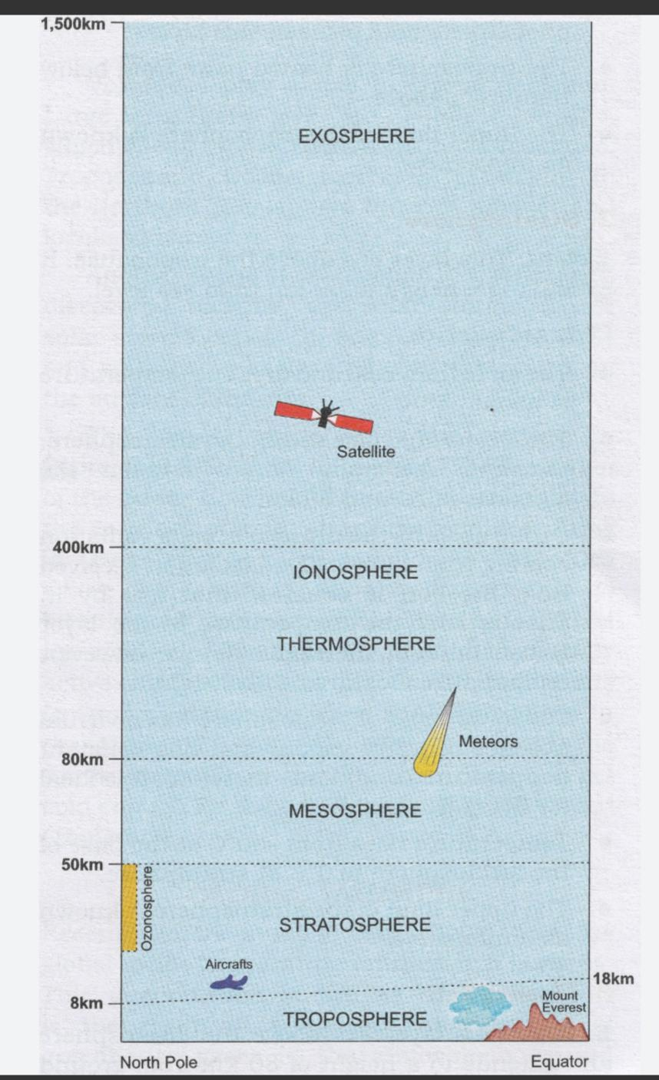

​

WORK SHEET FOR PRACTICE
MULTIPLE CHOICE QUESTIONS (1 Mark Each)
​Q1. In which layer of the Earth's atmosphere do humans live, and where do almost all weather phenomena take place?
(a) Stratosphere
(b) Tropopause
(c) Thermosphere
(d) Troposphere

​Q2. Which scale was invented by Anders Celsius for measuring temperature, and what are the freezing and boiling points of water on it?
(a) Fahrenheit scale; 32°F and 212°F
(b) Celsius scale; 0°C and 100°C
(c) Celsius scale; 15°C and 59°C
(d) Millibar scale; 0 mb and 100 mb
​
​Q3.Assertion (A): The troposphere is thinner at the poles and thicker in the tropical zone.
Reason (R): Cold air contracts at the poles, while warmer air expands in the tropical zone.

​Q4.Assertion (A): At high altitudes, people often feel breathless, dizzy, or tired.
Reason (R): The normal atmospheric pressure at the sea coast is around 1013 millibars.

​
​Q5. A team of scientists is setting up a weather station in a severe environment. They record a massive drop in atmospheric pressure from 1013 mb down to 985 mb. Based on the textbook data, what atmospheric event should they prepare for?
(a) A severe drought and heat wave
(b) A rapid expansion of the troposphere
(c) A low-pressure system or depression that may develop into a storm
(d) Liquid water freezing instantly into hard balls of ice

​Q6. Rohan noticed that in his town, wet clothes took an exceptionally long time to dry on Tuesday compared to Monday, even though the temperature remained exactly the same. What change in the weather elements explains this application of science?
(a) Atmospheric pressure dropped dramatically on Tuesday.
(b) The relative humidity increased significantly on Tuesday, slowing down evaporation.
(c) The wind direction shifted from North to South.
(d) Sleet and hail fell continuously from the sky on Tuesday.

​Q7. An Indian Army squad is being deployed to serve at Khardung La in Ladakh, which is situated at an altitude of over 5,600 meters above sea level. Their medical officer advises them to make frequent pauses on their journey up to "acclimatize." Why is this situation-based pause mandatory?
(a) The air gets thicker, forcing the body to release excess water vapor.
(b) The atmospheric pressure drops to around 650 millibars, meaning the air is thinner and less oxygen is available.
(c) The wind speed drops to 0 km/h on the vertical shaft, causing solid freezing.
(d) The relative humidity at high altitudes instantly jumps to 100%, causing heavy rainfall.

​
​Q8. Consider the following three statements regarding weather forecasting and nature:
Statement 1: Traditional weather signals passed through generations include observing ants shifting eggs to higher ground before heavy rain.
Statement 2: Pine cones close their scales in dry conditions to release their seeds into the wind.
Statement 3: Modern meteorologists rely solely on guessing by looking up at the sky rather than using calibrated gadgets.
​Which of the choices below correctly identifies the true and false statements?
(a) Statement 1 is True; Statements 2 and 3 are False.
(b) Statements 1 and 2 are True; Statement 3 is False.
(c) All statements are True.
(d) Statement 2 is True; Statements 1 and 3 are False.

​SUBJECTIVE QUESTIONS
​Q11. Distinguish clearly between the terms "Weather" and "Meteorology" based on your textbook definitions.
Q12. Describe how an Automated Weather Station (AWS) works and list two fields or sectors where its real-time data is critical.
Q13. Define 'Relative Humidity'. Explain what 0% humidity and 100% humidity mean in environmental terms.
​Q14. Imagine Krishnan from Chennai is talking on the phone with Amir in Kashmir. Krishnan mentions that it has become "chilly" in Chennai at 20°C after a night rain. Amir laughs because 20°C feels warm and pleasant to him in Kashmir.
(a) Why do Krishnan and Amir have a conflicting understanding of what is "cold"?
(b) How does a standard weather instrument resolve this communication problem? State the instrument and its standard units.
​Q15. Suppose you want to track local rainfall patterns over a month.
(a) Name the instrument you will build or use, and detail its main structural components.
(b) Apply your knowledge of proper placement: Where should you set up this instrument on a school campus to get an accurate reading, and what precautions must you take to prevent faulty data?

​Q16. Read the excerpt and answer the questions that follow:
"Wind is the movement of air from areas of high pressure to areas of low pressure. Speed and direction are two important factors... Air pilots, sailors, and farmers need to be aware of wind data."
(a) Explain how a 'wind vane' (or wind sock) and an 'anemometer' function differently to provide comprehensive data to a pilot.
(b) Analyze why a farmer needs to look at wind direction and speed to safely manage their agricultural activities.

